**CSS Test**

**Q.1**

**Ans: The Box Model** is used to make the content more efficient. So the user or the viewer can see the code in better way.

It defines how the content inside the box should be displayed and applying with the CSS it can used in different ways

The components of the Box model are:

**Content :** Content is the actual thing which will be shown to the user

It me contains text, image, file, etc

**Padding:** Padding id used to give some space to the content.

The space between the content and the border is known as padding

It provides an extra space between content and boundary

**Margin:** Margin is the gap between the container and the boundary of the content.

**Working of Margin:**

**Div{**

**margin: 20px;**

**}**

Using the above code the margin will be applied to each side (top, right , bottom, left)

**Working of padding:**

**Div{**

**padding: 20px;**

**}**

This will provide a padding or we can say space between the content and the boundary.

**Q.2**

**Ans:**

1. **Inline:**

Doing inline the elements will be place one after other horizontally and it will take the required space only, not like the block level which take the whole width of the container.

Inline is used for the element to make the content more presentable

Ex. <span>, <em>, <strong>, <img>

1. **Block:**

Block elements means which contains the whole width of the container or screen width and that are place one after another vertically

Width and height properties are applicable in block.

Ex. <heading>, <p>, <div>

1. **Inline-block:**

inline-block are the block which act as a inline elements and also have properties of the block elements which are width and height

**Q.3**

**Ans: Specifier** is used for the CSS properties and very essential for the styling.

There are different by of specifier and use of them are also different

Example :

**Id specifier:**

Using this specifier one can give styling to the specific element and the css will be applied to those element only whose having the specific Id.

<head>

<style>

#ab{

Color:blue;

Background-color:green;

}

</style>

</head>

<body>

<p id=”ab”>Hello everyone</p>

</body>

**Class Specifier:**

Class Specifier is used to the whole class and the element present in those class will be applied to them

<head>

<style>

.e{

Color:blue;

Background-color:green;

}

</style>

</head>

<body>

<div class=”e”>

<p>Hello everyone</p>

<p>Hello</p>

<p>everyone</p>

</div>

</body>

**Element specific :**

In this the style will be applied to the elements which is their in the css

<head>

<style>

p.a{

Color:blue;

Background-color:green;

}

p.a{

Color:green;

Background-color:red;

}

p.a{

Color:brown;

Background-color:blue;

}

</style>

</head>

<body>

<div class=”e”>

<p class=”x”>Hello everyone</p>

<p class=”y”>Hello</p>

<p class=”z”>everyone</p>

</div>

</body>

**Q.4**

**Ans: Class selector** is the selector in which we can apply the css properties to the multiple elements in one go.

So one can apply the CSS on the class and every child element in that class will get the CSS which is defined for that class

“.” Is used for the css

Syntax for class selector:

<!doctype html>

<html>

<head>

<style>

.container{

Background-color: red;

color: white;

}

</style>

</head>

</html>

After applying this code every element inside this class will get the background as red and text color as white.

**Id selector** is the selector which is used to give properties or design it uniquely

It is used for unique selection of the element

“#” is used for the css.

Syntax for id selector:

<!doctype html>

<html>

<head>

<style>

#ab{

Background-color: blue;

color: orange;

}

</style>

</head>

</html>

After using the above code, those element whose id is given as “ab” will be having background as blue and text color as orange.

**Q.5**

**Ans: Media Query** is responsible for the responsiveness and the better view of the site. When the screen size or resolution changes so it will be adjusted by the media query

Syntax for the text responsive:

<!doctype html>

<html>

<head>

<style>

p{

font-size:1rem;

}

@media (max-width:600px){

p{

font-size:1.5rem;

}

}

</style>

</head>

<body>

<p>

Hello, my name is bharat.

</p>  
</body>

</html>

Q.6

Ans: Flex box is used to align items horizontally and vertically and it is used to design the div to make it look more effective

<!doctype html>

<html>

<head>

<style>

.con{

Display:”flex”

}

</style>

</head>

<body>

<div class=”con”>

<div class=”a”>one</div>

<div class=”a”>one</div>

<div class=”a”>one</div>

</div>  
</body>

</html>

Using the above code the div container will be in vertical

<!doctype html>

<html>

<head>

<style>

.con{

display:”flex”

flex-direction:”column”;

}

</style>

</head>

<body>

<div class=”con”>

<div class=”a”>one</div>

<div class=”a”>one</div>

<div class=”a”>one</div>

</div>  
</body>

</html>

Using the above code the div container will be in horizontal

Because we used the flex-direction column.

**Section B**

Q.1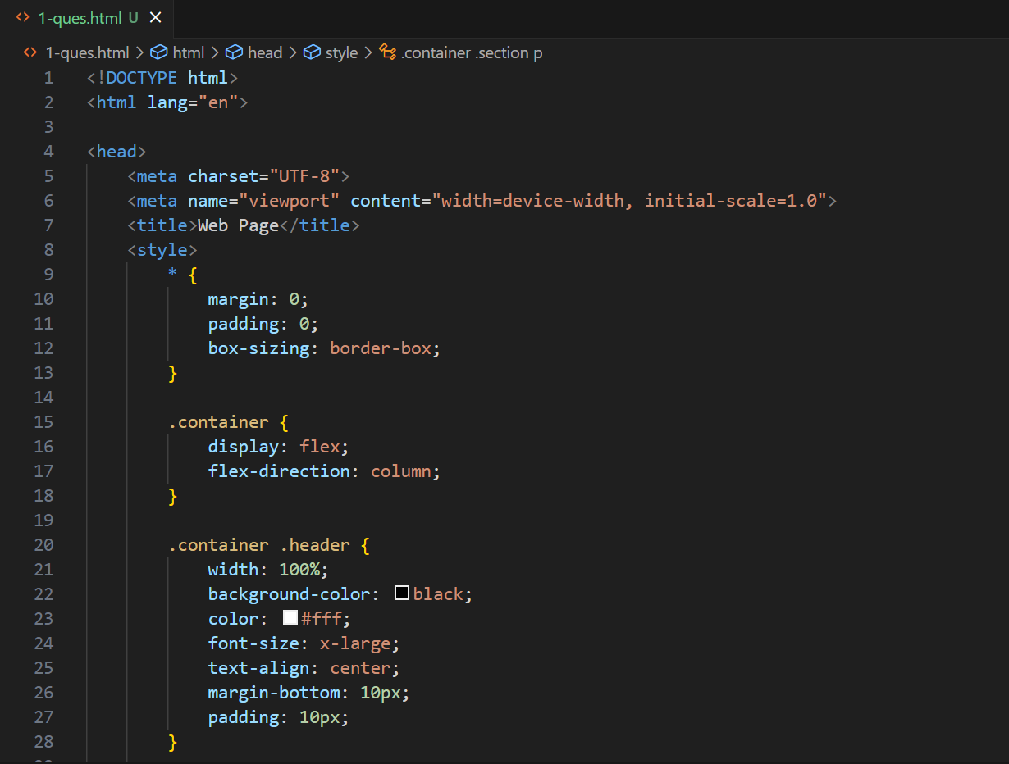

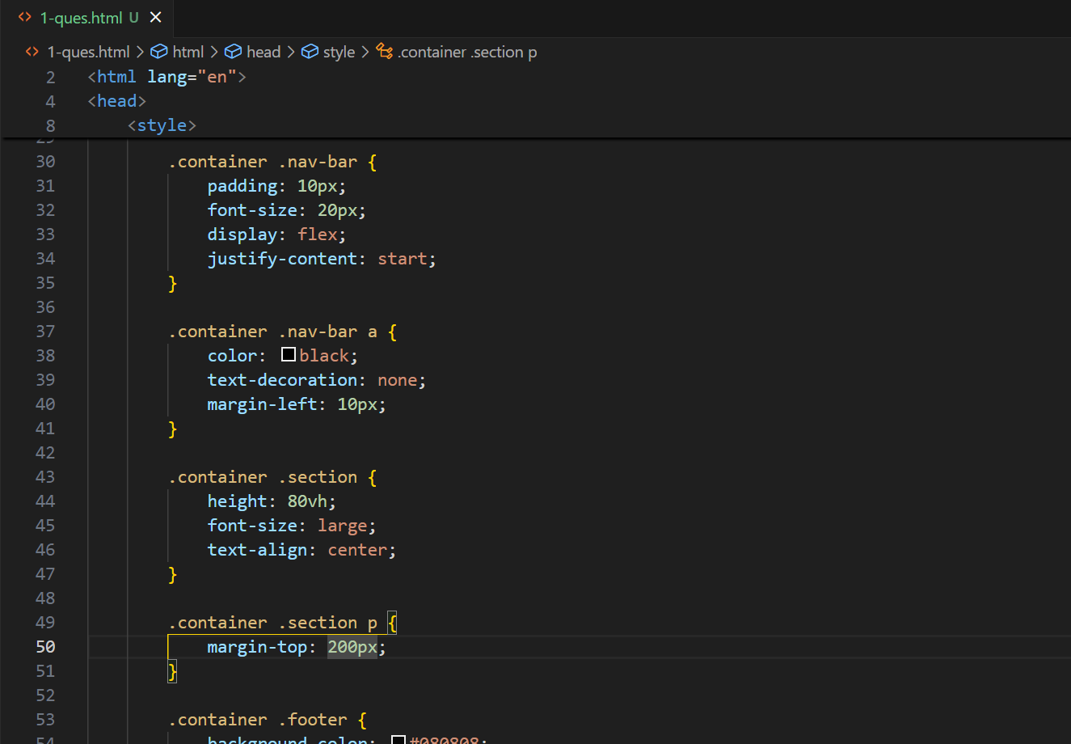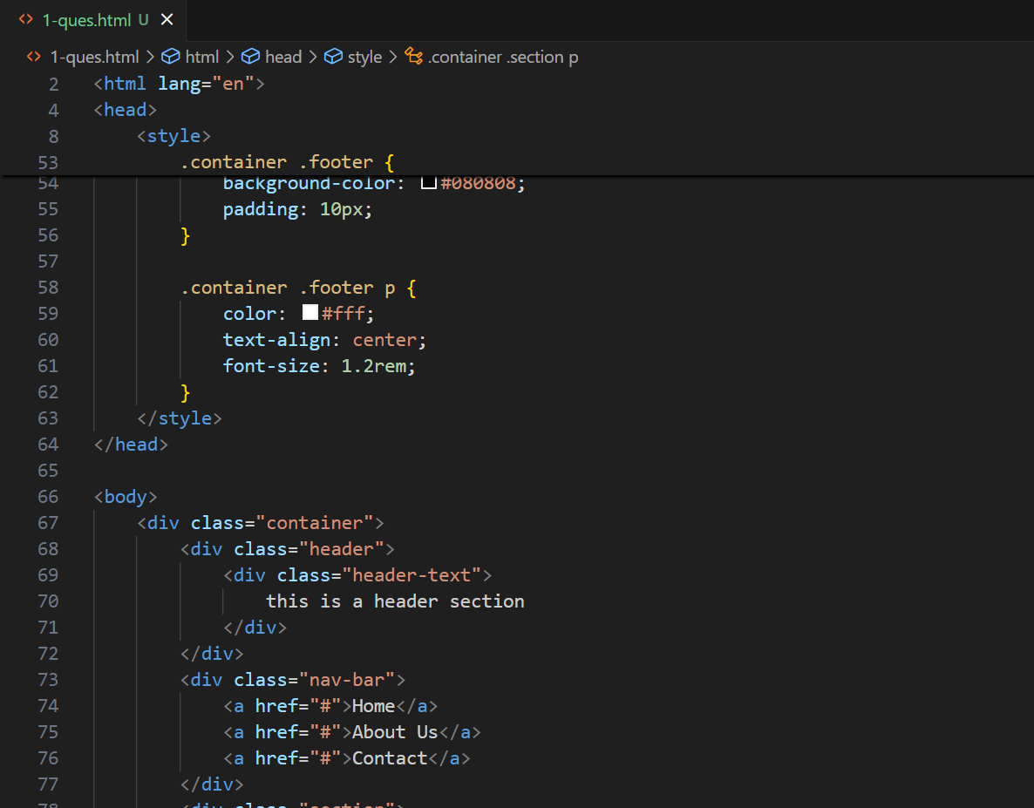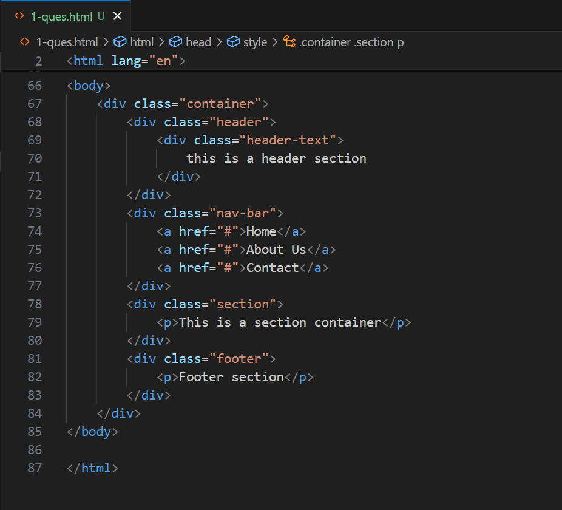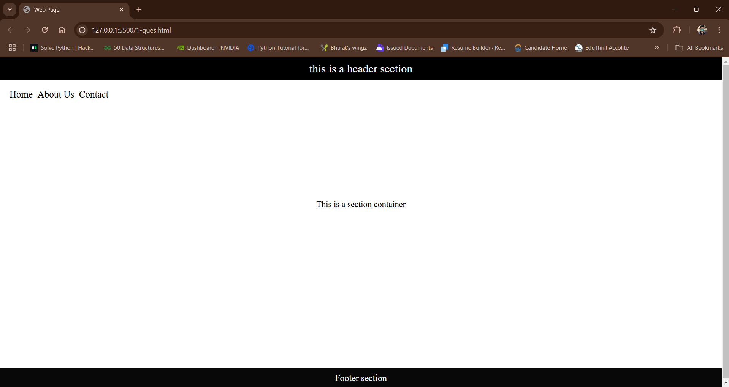

Q.2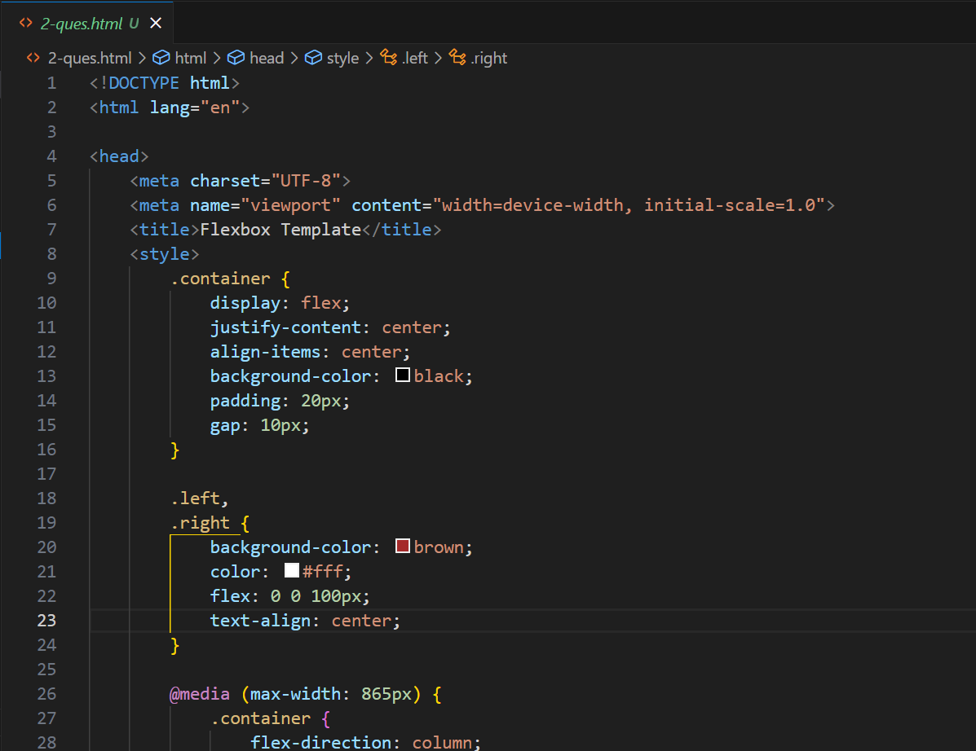

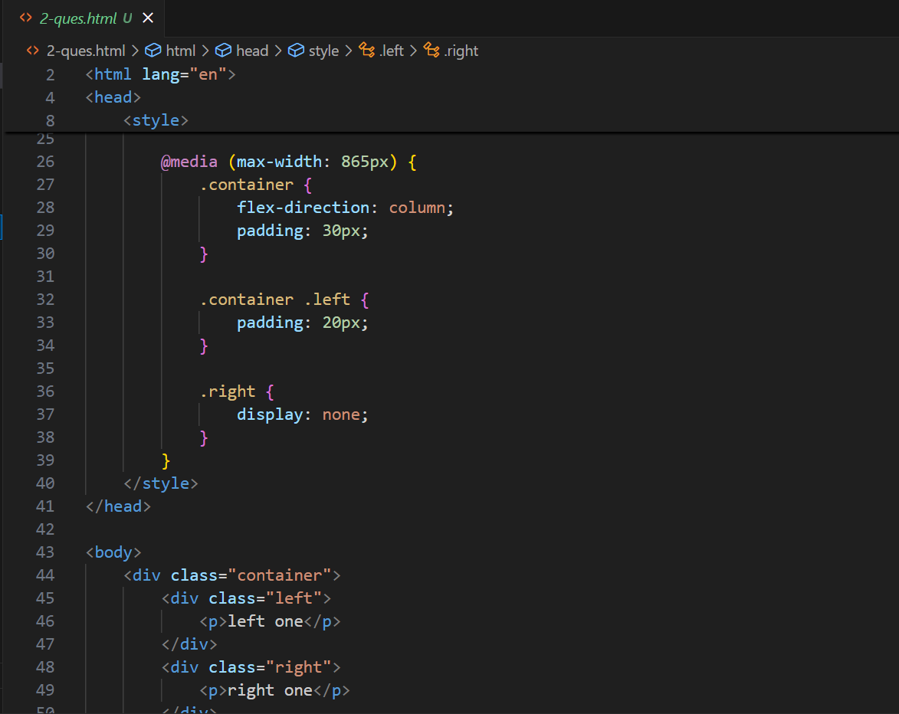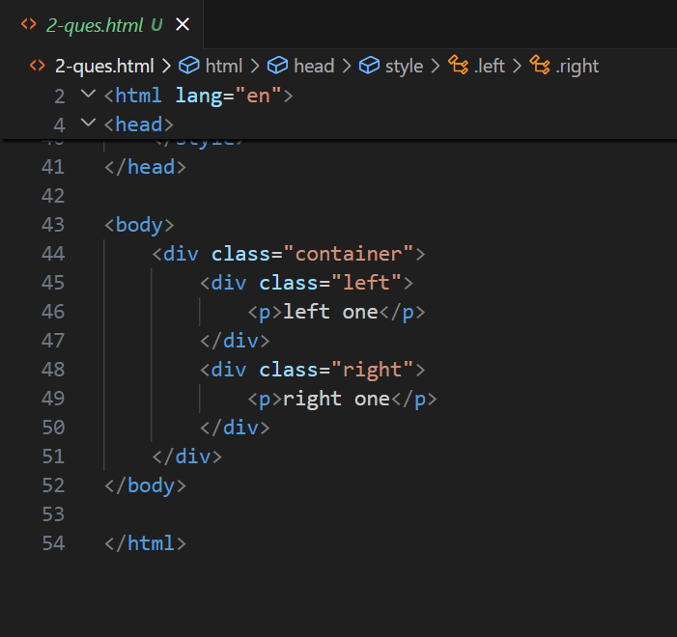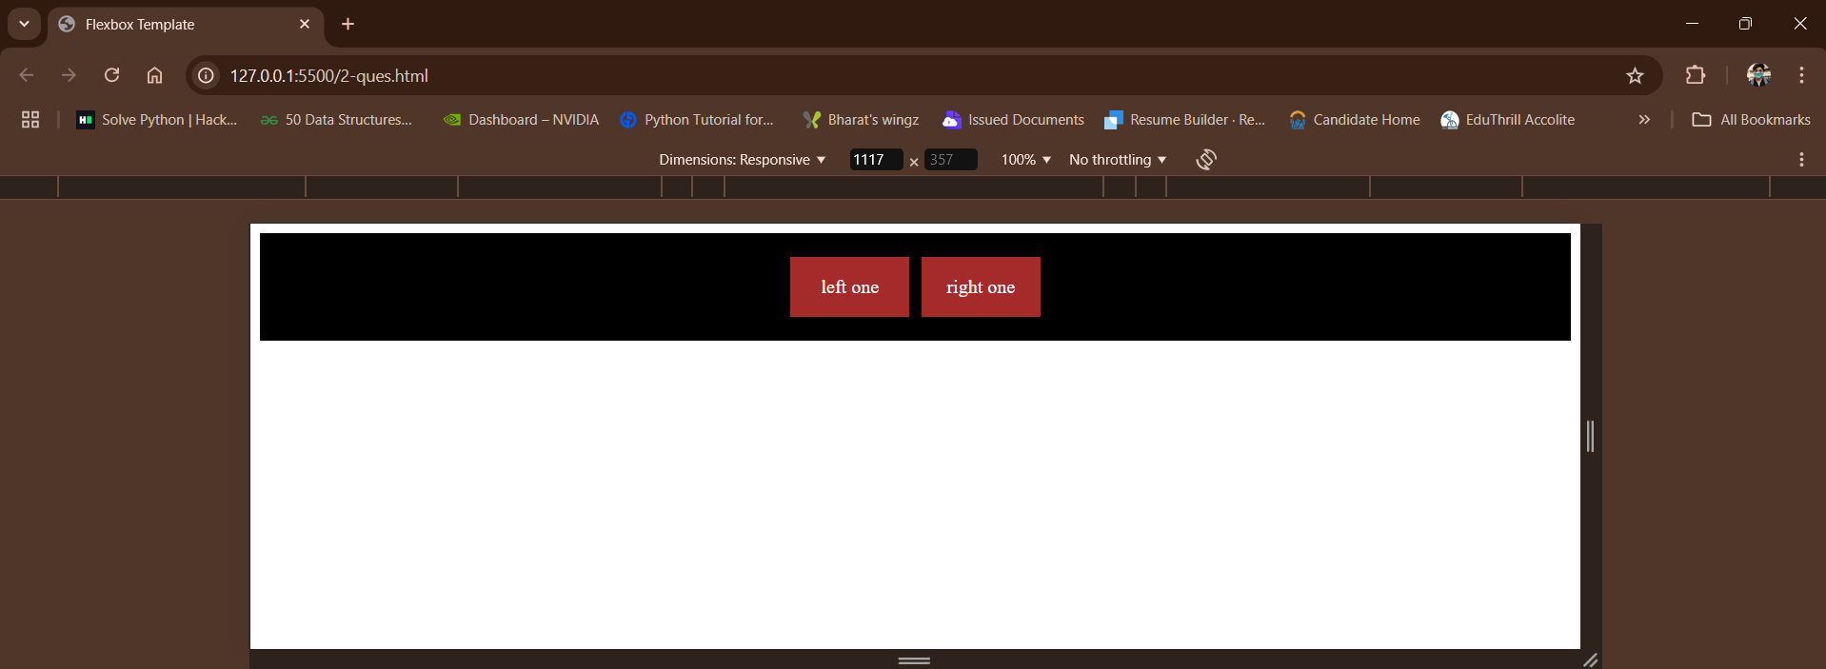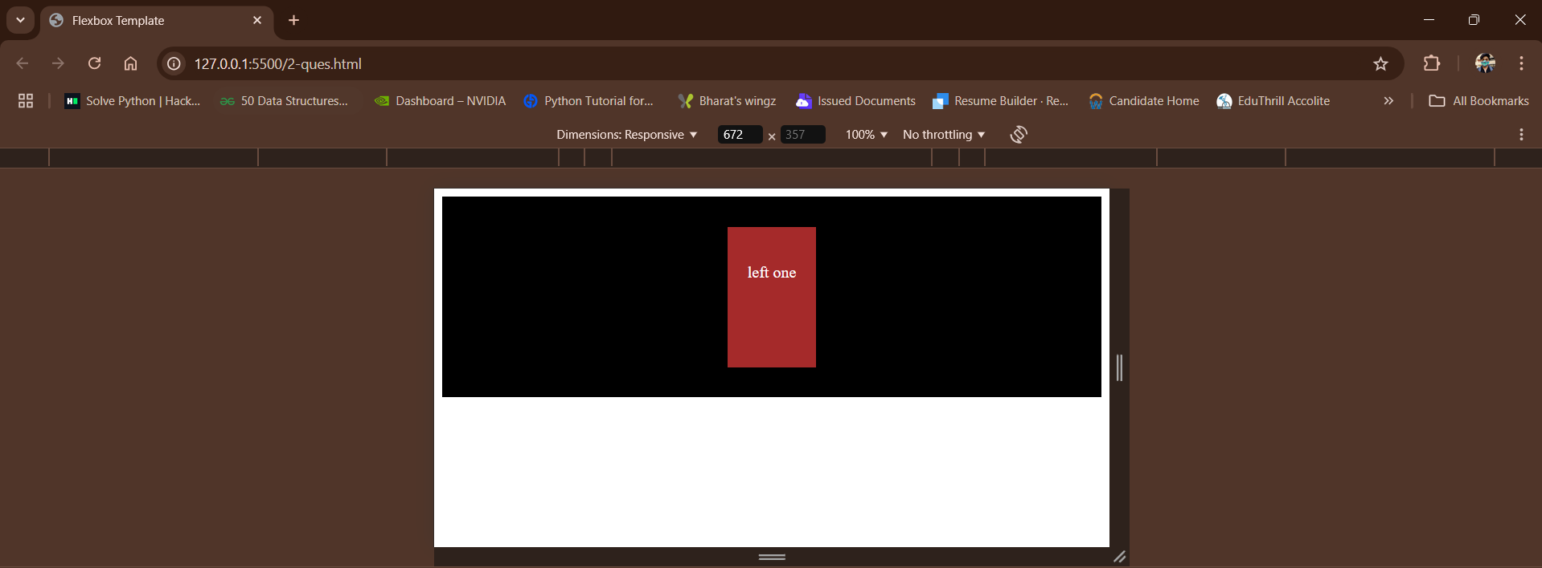

Q.3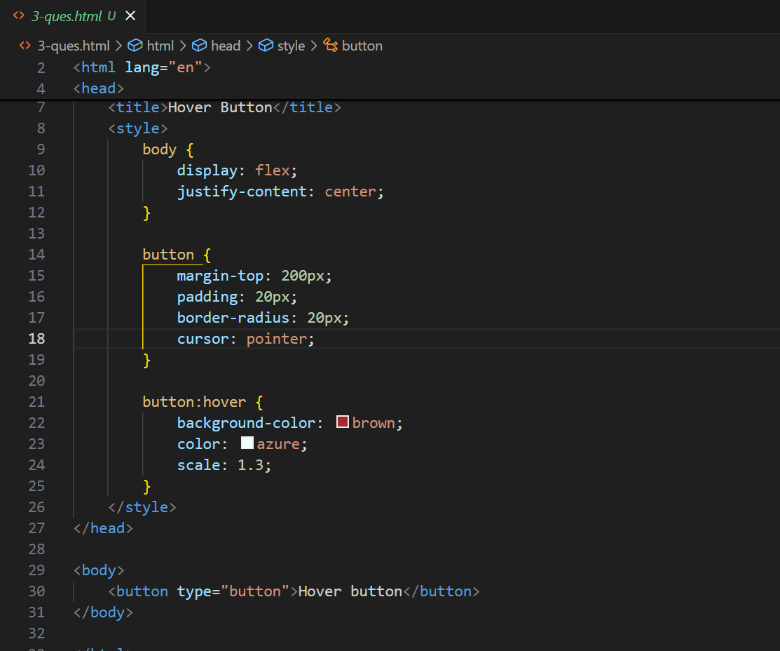

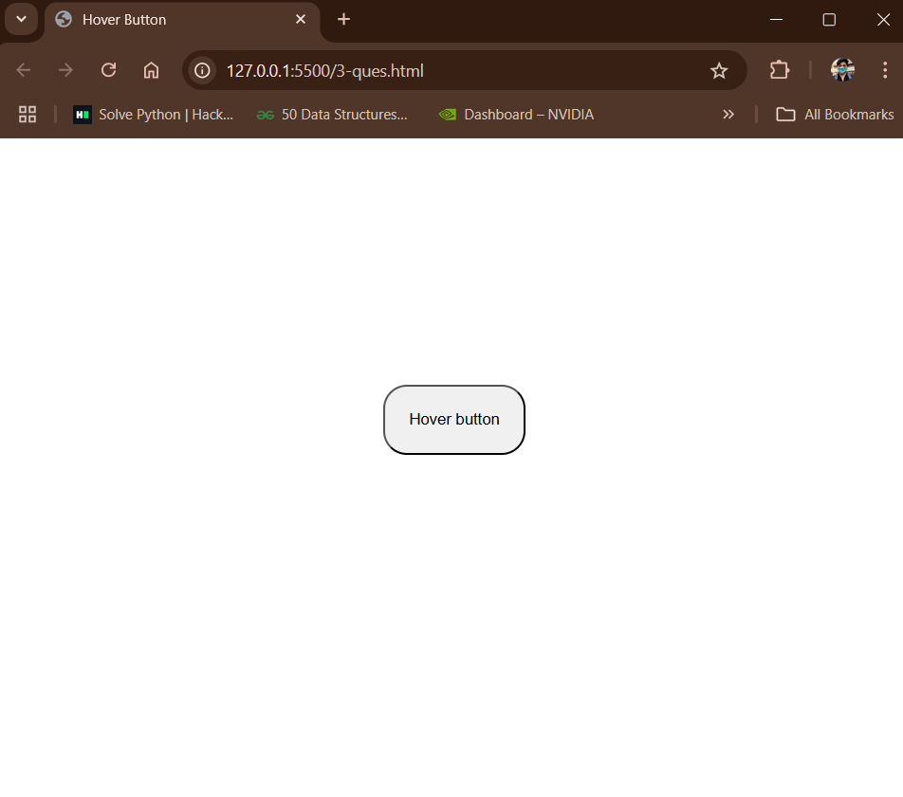

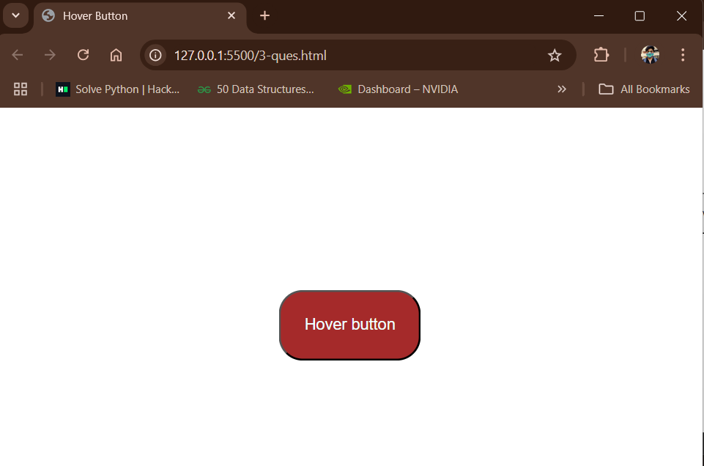

Q.4